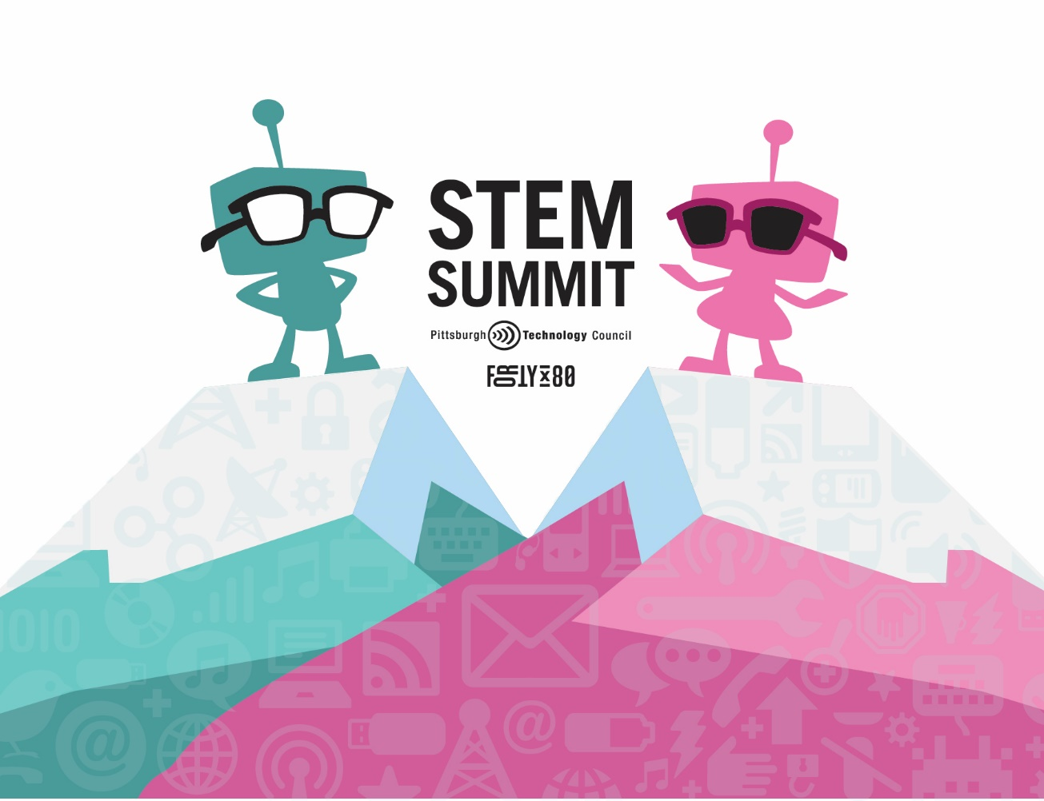
STEM Summit 2025
STEM Careers in Action | April 4, 2025
CCAC and Multiple Tour Stops

The 2025 STEM Summit offers high school students unique opportunities to explore career pathways and engage with industry professionals. Showcasing the wide range of STEM-related careers available in Pittsburgh and the surrounding region, this day offers experiential learning opportunities at CCAC. Students will also participate in industry tours and connect directly with STEM professionals.
Designed for students with a passion for innovation, the STEM Summit provides an immersive experience that inspires and equips the next generation of STEM leaders.

CONTRIBUTION & SPONSORSHIP OPPORUTNITIES
Tour Spot Sponsor
- Three (3) event tickets
- Acknowledgment in the opening remarks
- Recognition on all digital marketing materials & event signage as "Tour Spot Sponsor”
- Opportunity to host students on a tour
- List of attendees post-event (attendee name, title and company only)
Sponsorship Investment: Cost dependent on company size ($1,500 - $5,000)

Student Scholarship Sponsor
- Two (2) event tickets
- Acknowledgment in the opening remarks
- Recognition on all digital marketing materials & event signage as "Student Scholarship Sponsor”
- Opportunity to sponsor an under-resourced school district to come to the STEM Summit
- List of attendees post-event (attendee name, title and company only)
- Company logo included on the STEM Summit Website
Sponsorship Investment: $2,500

Lanyard Sponsor
- Two (2) complimentary tickets to the event
- Opportunity to have your logo on the lanyard
- Recognition on all marketing materials & event/digital signage as “Lanyard Sponsor”
- Recognition as “Lanyard Sponsor” included in all emails regarding the event and in any online event advertisements
- Company logo included on the STEM Summit Website
Sponsorship Investment: $2,000

Additional Options
Exhibitor Table
- Two (2) event tickets
- Acknowledgment in the opening remarks
- Company logo included on the STEM Summit Website
- Booth at host site to connect with teachers and students
Sponsorship Investment: $850

