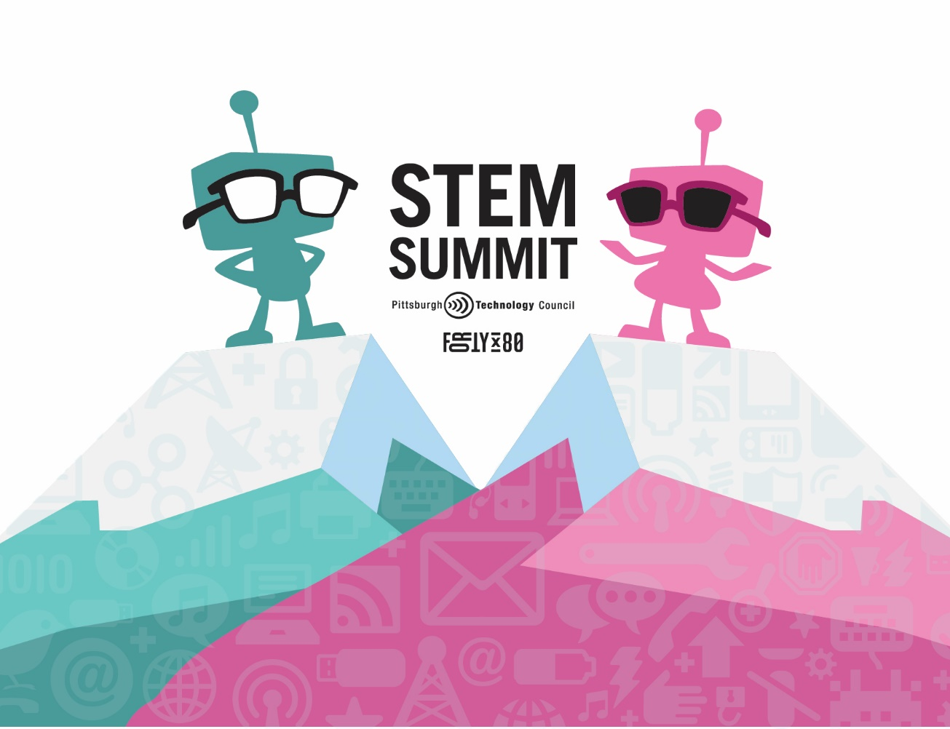
STEM Summit 2025
Forge the Future | April 2, 2025
Digital Foundry, Penn State, New Kensington

Focused on Advanced Manufacturing, this day includes industry tours and hands-on experiences designed to highlight innovative career paths in this cutting-edge field. Students will start the day with experiential learning opportunities at the Digital Foundry at PSU New Kensington and participate in industry tours and connect directly with STEM professionals.

CONTRIBUTION & SPONSORSHIP OPPORUTNITIES
Tour Spot Sponsor
- Three (3) event tickets
- Acknowledgment in the opening remarks
- Recognition on all digital marketing materials & event signage as "Tour Spot Sponsor”
- Opportunity to host students on a tour
- List of attendees post-event (attendee name, title and company only)
Sponsorship Investment: Cost dependent on company size ($1,500 - $5,000)

Student Scholarship Sponsor
- Two (2) event tickets
- Acknowledgment in the opening remarks
- Recognition on all digital marketing materials & event signage as "Student Scholarship Sponsor”
- Opportunity to sponsor an under-resourced school district to come to the STEM Summit
- List of attendees post-event (attendee name, title and company only)
- Company logo included on the STEM Summit Website
Sponsorship Investment: $2,500

Lanyard Sponsor
- Two (2) complimentary tickets to the event
- Opportunity to have your logo on the lanyard
- Recognition on all marketing materials & event/digital signage as “Lanyard Sponsor”
- Recognition as “Lanyard Sponsor” included in all emails regarding the event and in any online event advertisements
- Company logo included on the STEM Summit Website
Sponsorship Investment: $2,000

Additional Options
Exhibitor Table
- Two (2) event tickets
- Acknowledgment in the opening remarks
- Company logo included on the STEM Summit Website
- Booth at host site to connect with teachers and students
Sponsorship Investment: $850

